Year 12-13 Transition Booklet

Pure Mathematics
Students Copy

Name
Teacher

Contents
- Surds and Indices 2
- Completing the square 5
- Simultaneous Equations and Discriminant 11
- Inequalities 18
- Curve Sketching 22
- Functions, sketching & transformations 26
- Coordinate Geometry 33
- Sequences and Series 40
- Differentiation 50
- Integration 57
- Partial Fractions ( Year 2)……………………………………….

Surds and Indices

HOMEWORK MARK | SUBMISSION DATE |  | TARGET GRADE | HOMEWORK GRADE
SECTION B: SELF ASSESSMENT (to be completed by student)
Please identify the areas in which you feel you have strengths and those in which you need to improve. Provide evidence to support yourself assessment with reference to the content of your
homework.
STRENGTHS |  | AREAS FOR IMPROVEMENT
SECTION C: TUTOR FEEDBACK
STRENGTHS |  | AREAS FOR IMPROVEMENT

1. Write

√(75) – √(27)

in the form k √x, where k and x are integers.
(Total 2 marks)
4

2. (a) Find the value of 8 3 .
(2)

4

15x 3
(b) Simplify . 3x
(2)
(Total 4 marks)

- Simplify

  - (3 √7)²
(1)

  - (8 + √5)(2 – √5)
(3)
(Total 4 marks)
4. (a) Expand and simplify (7 + √5)(3 – √5).
(3)

7 + 5
(b) Express in the form a + b √5, where a and b are integers.
3 + 5
(3)
(Total 6 marks)

Completing the square

HOMEWORK MARK | SUBMISSION DATE |  | TARGET GRADE | HOMEWORK GRADE
SECTION B: SELF ASSESSMENT (to be completed by student)
Please identify the areas in which you feel you have strengths and those in which you need to improve. Provide evidence to support yourself assessment with reference to the content of your
homework.
STRENGTHS |  | AREAS FOR IMPROVEMENT
SECTION C: TUTOR FEEDBACK
STRENGTHS |  | AREAS FOR IMPROVEMENT

Q1.

where p and q are integers.

Find the value of p and the value of q.

(3)

(Total 3 marks)

Q2.

Show that x² + 6x + 11 can be written as

where p and q are integers to be found.

(2)

(Total 2 marks)

Q3.

f(x) = x² + 4kx + (3+11k), where k is a constant.

Express f(x) in the form (x + p)² + q, where p and q are constants to be found in terms of k.

(3)

(Total 3 marks)

Q4.

Given that

f(x) = 2x² + 8x + 3

- find the value of the discriminant of f(x).

- Express f(x) in the form p(x + q)² + r where p, q and r are integers to be found.

(2)

(3)

(Total 5 marks)

Simultaneous Equations and Discriminant

HOMEWORK MARK | SUBMISSION DATE |  | TARGET GRADE | HOMEWORK GRADE
SECTION B: SELF ASSESSMENT (to be completed by student)
Please identify the areas in which you feel you have strengths and those in which you need to improve. Provide evidence to support yourself assessment with reference to the content of your homework.
STRENGTHS |  | AREAS FOR IMPROVEMENT
SECTION C: TUTOR FEEDBACK
STRENGTHS |  | AREAS FOR IMPROVEMENT

Q1. Solve the simultaneous equations
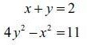

(7)

(Total 7 marks)

Q2.

Solve the simultaneous equations

y − 3x + 2 = 0
y² − x − 6x² = 0

(7)

(Total 7 marks)

Q3.

Given the simultaneous equations

where k is a non zero constant,

2x + y = 1
x² − 4ky + 5k = 0

- show that

Given that x² + 8kx + k = 0 has equal roots,
- find the value of k.

x² + 8kx + k = 0

(2)

(3)

- For this value of k, find the solution of the simultaneous equations.

(3)

(Total 8 marks)

Q4.

Given that

f(x) = 2x² + 8x + 3

- find the value of the discriminant of f(x).

- Express f(x) in the form p(x + q)² + r where p, q and r are integers to be found.

(2)

(3)

(Total 5 marks)

Inequalities

HOMEWORK MARK | SUBMISSION DATE |  | TARGET GRADE | HOMEWORK GRADE
SECTION B: SELF ASSESSMENT (to be completed by student)
Please identify the areas in which you feel you have strengths and those in which you need to improve. Provide evidence to support yourself assessment with reference to the content of your
homework.
STRENGTHS |  | AREAS FOR IMPROVEMENT
SECTION C: TUTOR FEEDBACK
STRENGTHS |  | AREAS FOR IMPROVEMENT

- Find the set of values of x for which

x ² – 7x – 18 > 0.

(Total 4 marks)

- Find the set of values of x for which

  - 3(x – 2) < 8 – 2x

(2)

  - (2x – 7)(1 + x) < 0

(3)

  - both 3(x – 2) < 8 – 2x and (2x – 7)(1 + x) < 0

(1)
(Total 6 marks)

- Find the set of values of x for which

  - 4x – 3 > 7 – x

  - 2x² – 5x – 12 < 0

  - both 4x – 3 > 7 – x and 2x² – 5x – 12 < 0

(2)

(4)

(1)
(Total 7 marks)

Curve Sketching

HOMEWORK MARK | SUBMISSION DATE |  | TARGET GRADE | HOMEWORK GRADE
SECTION B: SELF ASSESSMENT (to be completed by student)
Please identify the areas in which you feel you have strengths and those in which you need to improve. Provide evidence to support yourself assessment with reference to the content of your
homework.
STRENGTHS |  | AREAS FOR IMPROVEMENT
SECTION C: TUTOR FEEDBACK
STRENGTHS |  | AREAS FOR IMPROVEMENT

1.
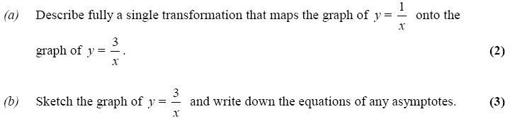

2.
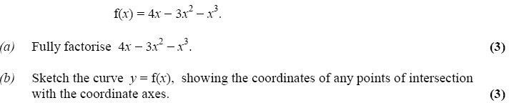

3.
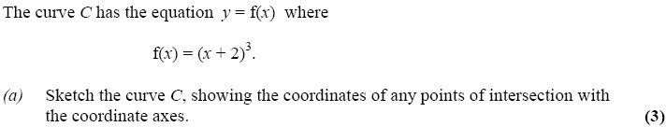

Functions, sketching & transformations

HOMEWORK MARK | SUBMISSION DATE |  | TARGET GRADE | HOMEWORK GRADE
SECTION B: SELF ASSESSMENT (to be completed by student)
Please identify the areas in which you feel you have strengths and those in which you need to improve. Provide evidence to support yourself assessment with reference to the content of your homework.
STRENGTHS |  | AREAS FOR IMPROVEMENT
SECTION C: TUTOR FEEDBACK
STRENGTHS |  | AREAS FOR IMPROVEMENT

- (a) On the axes below sketch the graphs of

  - y = x (4 – x)

  - y = x² (7 – x)
showing clearly the coordinates of the points where the curves cross the coordinate axes.

(5)

- Show that the x-coordinates of the points of intersection of

y = x (4 – x) and y = x² (7 – x)

are given by the solutions to the equation x(x² – 8x + 4) = 0

(3)

The point A lies on both of the curves and the x and y coordinates of A are both positive.

- Find the exact coordinates of A, leaving your answer in the form (p + q√3, r + s√3), where p, q, r and s are integers.
(7)
(Total 15 marks)

- (a) Factorise completely x³ - 4x.

- Sketch the curve with equation y = x³ - 4x, showing the coordinates of the points where the curve crosses the x-axis.

(3)

(3)

- On a separate diagram, sketch the curve with equation

y = (x - 1)³ - 4(x - 1),

showing the coordinates of the points where the curve crosses the x-axis.

(3)
(Total 9 marks)

- (a) Factorise completely x³ – 6x² + 9x

(3)

- Sketch the curve with equation

y = x³ – 6x² + 9x

showing the coordinates of the points at which the curve meets the x-axis.

(4)

Using your answer to part (b), or otherwise,

- sketch, on a separate diagram, the curve with equation

y = (x – 2)³ – 6(x – 2)² + 9(x – 2)

showing the coordinates of the points at which the curve meets the x-axis.

(2)

(Total 9 marks)

Coordinate Geometry

HOMEWORK MARK | SUBMISSION DATE |  | TARGET GRADE | HOMEWORK GRADE
SECTION B: SELF ASSESSMENT (to be completed by student)
Please identify the areas in which you feel you have strengths and those in which you need to improve. Provide evidence to support yourself assessment with reference to the content of your
homework.
STRENGTHS |  | AREAS FOR IMPROVEMENT
SECTION C: TUTOR FEEDBACK
STRENGTHS |  | AREAS FOR IMPROVEMENT

Q1.

The points P and Q have coordinates (−1, 6) and (9, 0) respectively.
The line l is perpendicular to PQ and passes through the mid-point of PQ.
Find an equation for l, giving your answer in the form ax + by + c = 0, where a, b and c are integers.

(5)

(Total 5 marks)

Q2.

The line l₁ has equation 3x + 5y − 2 = 0
- Find the gradient of l₁.

The line l₂ is perpendicular to l₁ and passes through the point (3, 1).
- Find the equation of l₂ in the form y = mx + c, where m and c are constants.

(2)

(3)

(Total 5 marks)

Q3.

The straight line L₁ passes through the points (−1, 3) and (11, 12).

- Find an equation for L₁ in the form ax + by + c = 0, where a, b and c are integers.

(4)

The line L₂ has equation 3y + 4x − 30 = 0.

- Find the coordinates of the point of intersection of L₁ and L₂.

(3)

(Total 7 marks)

Q4.

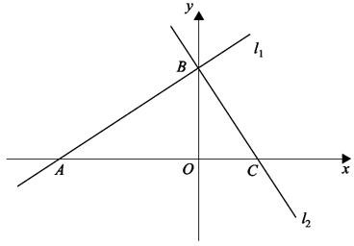

Figure 1

The line l₁ has equation 2x − 3y + 12 = 0
- find the gradient of l₁.

The line l₁ crosses the x-axis at the point A and the y-axis at the point B, as shown in Figure 1. The line l₂ is perpendicular to l₁ and passes through B.
- Find an equation of l₂.

The line l₂ crosses the x-axis at the point C.
- Find the area of triangle ABC.

(1)

(3)

(4)

(Total 8 marks)

Sequences and Series

HOMEWORK MARK | SUBMISSION DATE |  | TARGET GRADE | HOMEWORK GRADE
SECTION B: SELF ASSESSMENT (to be completed by student)
Please identify the areas in which you feel you have strengths and those in which you need to improve. Provide evidence to support yourself assessment with reference to the content of your
homework.
STRENGTHS |  | AREAS FOR IMPROVEMENT
SECTION C: TUTOR FEEDBACK
STRENGTHS |  | AREAS FOR IMPROVEMENT

- A sequence of positive numbers is defined by

an+1 =
(a ² + 3,
n ≥ 1,

a1 = 2
n

  - Find a₂ and a₃, leaving your answers in surd form.

(2)

  - Show that a₅ = 4

(2)
(Total 4 marks)

- A sequence x₁, x₂, x₃, … is defined by

x₁ = 1,

x_{n+1} = ax_{n} – 3, n > 1,

where a is a constant.

  - Find an expression for x₂ in terms of a.

  - Show that x₃ = ax₂ – 3a – 3.

(2)

Given that x₃ = 7,

  - find the possible values of a.

(3)
(Total 6 marks)

- A 40-year building programme for new houses began in Oldtown in the year 1951 (Year 1) and finished in 1990 (Year 40).

The numbers of houses built each year form an arithmetic sequence with first term a
and common difference d.

Given that 2400 new houses were built in 1960 and 600 new houses were built in 1990, find

- the value of d,

(3)

- the value of a,

(2)

- the total number of houses built in Oldtown over the 40-year period.

(3)
(Total 8 marks)

- A sequence a₁, a₂, a₃ ... , is defined by

a₁ = k,

a_{n+1} = 3a_{n} + 5, n ≥ 1, where k is a positive integer.

- Write down an expression for a₂ in terms of k.

(1)

- Show that a₃ = 9k + 20.

(2)

4
- (i) Find ∑ ar
r =1

in terms of k.

4
(ii) Show that ∑ ar
r =1

is divisible by 10.

(4)
(Total 7 marks)

- The sum of an arithmetic series is
n

∑(80 − 3r)
r =1

- Write down the first two terms of the series.

(2)

- Find the common difference of the series.

Given that n = 50,

- find the sum of the series.

(3)
(Total 6 marks)

Differentiation

HOMEWORK MARK | SUBMISSION DATE |  | TARGET GRADE | HOMEWORK GRADE
SECTION B: SELF ASSESSMENT (to be completed by student)
Please identify the areas in which you feel you have strengths and those in which you need to improve. Provide evidence to support yourself assessment with reference to the content of your
homework.
STRENGTHS |  | AREAS FOR IMPROVEMENT
SECTION C: TUTOR FEEDBACK
STRENGTHS |  | AREAS FOR IMPROVEMENT

¹ dy
1. Given that y = x⁴ + x 3 + 3, find .
dx
(Total 3 marks)
2. Given that

₃ 3x² + 2
y = 8x − 4 x + , x > 0
x

dy
find .
dx
(Total 6 marks)

- Given that
3

2x ² − x 2

, can be written in the form
x

2x ^{p} − x^{q} ,

  - write down the value of p and the value of q.

(2)

Given that

y = 5x ²

− 3 +
3

2x ² − x 2
,
x

  - find
dy , simplifying the coefficient of each term.
dx

(4)
(Total 6 marks)

- The curve C has equation

y = (x + 3)(x − 8) ,
x

x > 0

dy
- Find in its simplest form.
dx

(4)

- Find an equation of the tangent to C at the point where x = 2

(4)
(Total 8 marks)

- The curve C has equation

y = x³ – 2x² – x + 9, x > 0

The point P has coordinates (2, 7).

  - Show that P lies on C.

  - Find the equation of the tangent to C at P, giving your answer in the form y = mx
+ c, where m and c are constants.

(5)

The point Q also lies on C.

Given that the tangent to C at Q is perpendicular to the tangent to C at P,

  - show that the x-coordinate of Q is
1 (2 +
3

6).

(5)
(Total 11 marks)

Integration

HOMEWORK MARK | SUBMISSION DATE |  | TARGET GRADE | HOMEWORK GRADE
SECTION B: SELF ASSESSMENT (to be completed by student)
Please identify the areas in which you feel you have strengths and those in which you need to improve. Provide evidence to support yourself assessment with reference to the content of your
homework.
STRENGTHS |  | AREAS FOR IMPROVEMENT
SECTION C: TUTOR FEEDBACK
STRENGTHS |  | AREAS FOR IMPROVEMENT

- Find

1
∫(8x³ + 6x 2 − 5)dx

giving each term in its simplest form.
(Total 4 marks)

- Find
∫(3x² + 4x⁵ − 7)dx .

(Total 4 marks)

- dy = 5x
dx
− 1
2 + x
x,

x > 0

Given that y = 35 at x = 4, find y in terms of x, giving each term in its simplest form.
(Total 7 marks)

- A curve has equation y = f(x) and passes through the point (4, 22). Given that
1
f'(x) = 3x ² − 3x 2 − 7,

use integration to find f(x), giving each term in its simplest form.
(Total 5 marks)

- The curve C has equation y = f(x), x > 0, where

dy = 3x − 5 − 2 dx
x

Given that the point P (4, 5) lies on C, find

  - f(x),

(5)

  - an equation of the tangent to C at the point P, giving your answer in the form
ax + by + c = 0, where a, b and c are integers.

(4)

(Total 9 marks)

- The curve C has equation y = f(x), x > 0, and f ′(x) = 4x − 6
+ 8 .
x 2
x

Given that the point P (4, 1) lies on C,

- find f(x) and simplify your answer.

(6)

- Find an equation of the normal to C at the point P (4, 1).

(4)
(Total 10 marks)

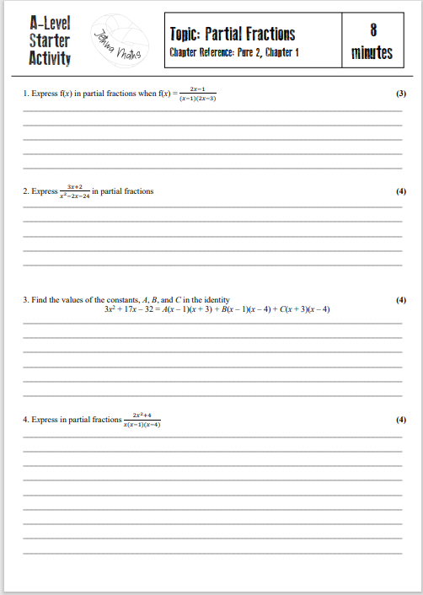
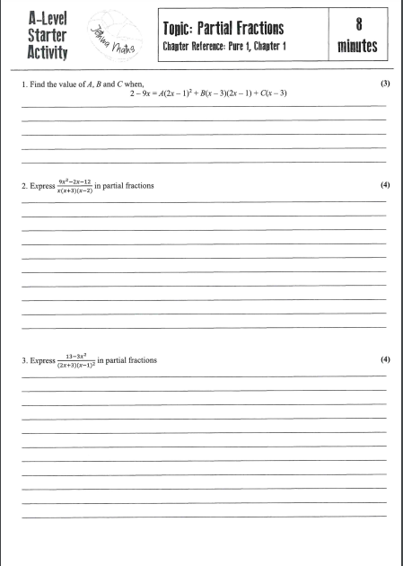

Partial Fractions (year 2 content)

HOMEWORK MARK | SUBMISSION DATE |  | TARGET GRADE | HOMEWORK GRADE
SECTION B: SELF ASSESSMENT (to be completed by student)
Please identify the areas in which you feel you have strengths and those in which you need to improve. Provide evidence to support yourself assessment with reference to the content of your
homework.
STRENGTHS |  | AREAS FOR IMPROVEMENT
SECTION C: TUTOR FEEDBACK
STRENGTHS |  | AREAS FOR IMPROVEMENT

