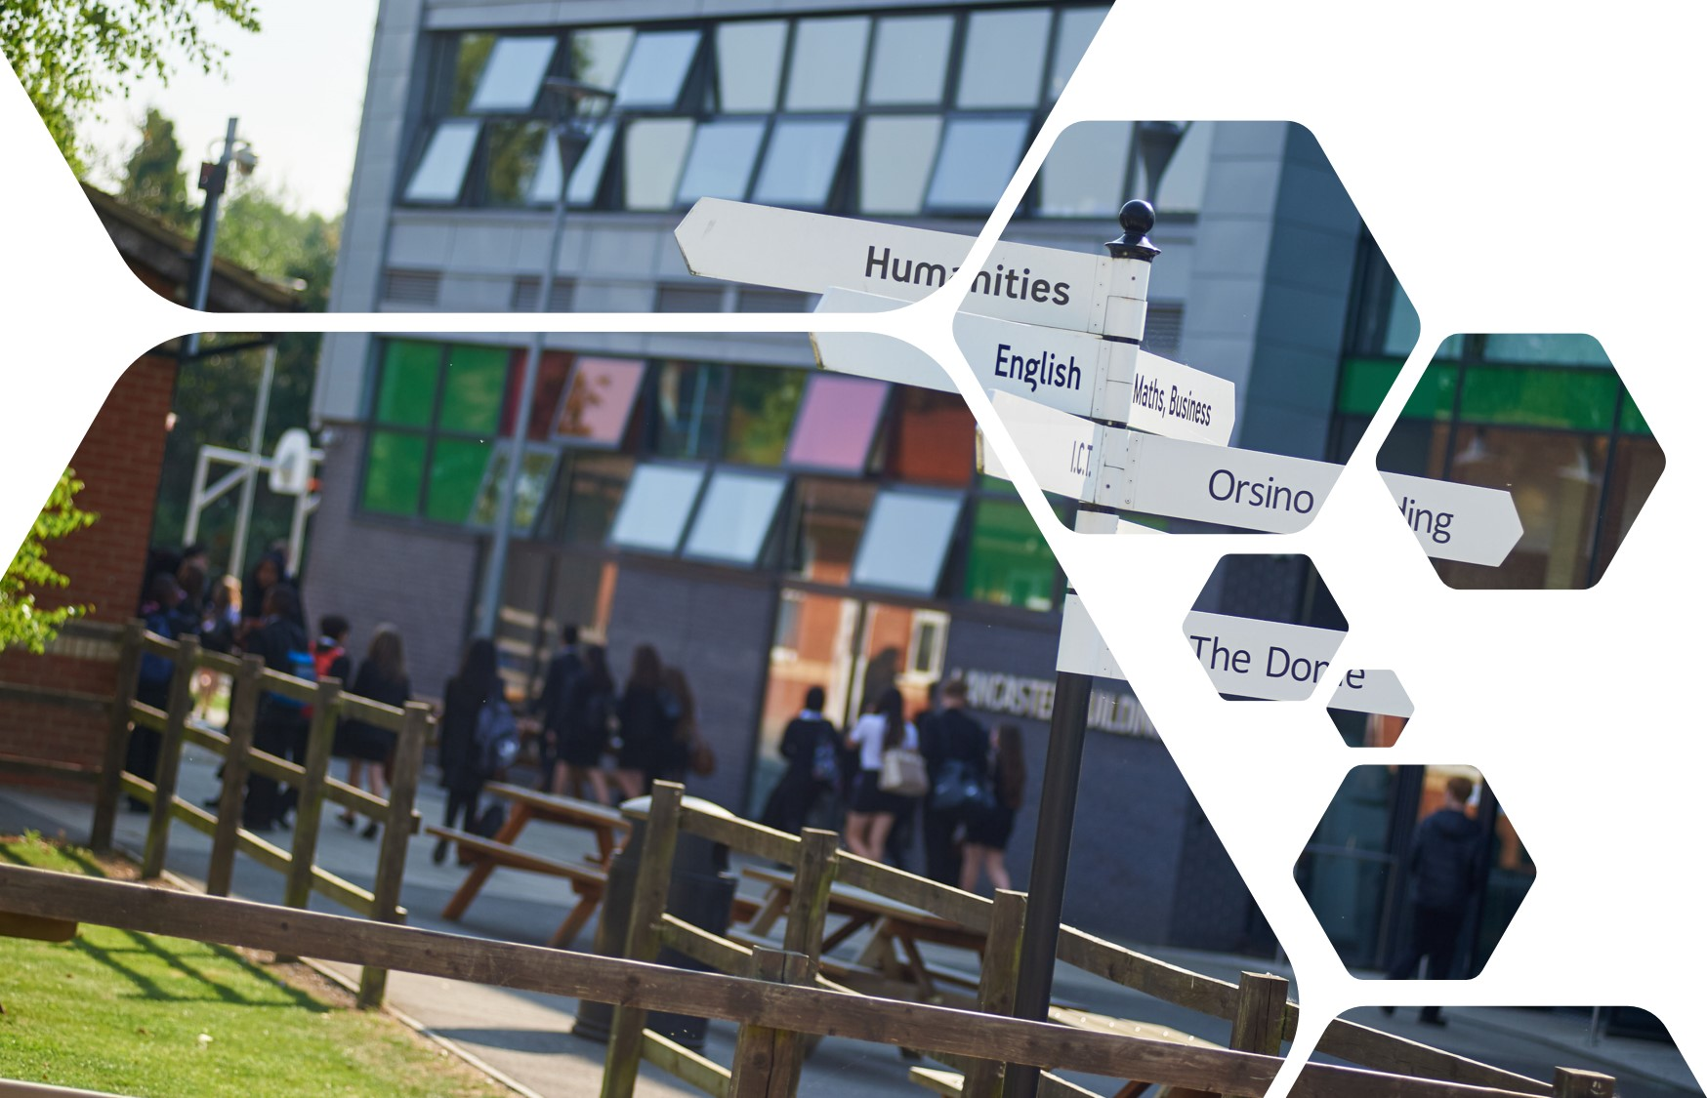

Sixth Form Transition Pack
Product Design

cOURSE INTRODUCTION
Throughout the course you will look at the physical and working properties of a wide range of materials and components so that you can develop an understanding of why they are used in different applications. You will also consider their manufacture, use and life span of a product. Through manufacturing and design you will identify safe working practices and understand the various processes that can apply to a product. You will then apply this knowledge to produce a physical prototype that communicates your research, design, practical work and evaluation to others.

“The true sign of intelligence is not knowledge, but imagination.”
Albert Einstein

Essential summer reading

AQA AS/A-Level Design and Technology: Product Design Paperback
by Will Potts (Author), Julia Morrison (Author), Ian Granger (Author), Dave Sumpner (Author)
ISBN-13: 978-1510432291

Essential summer listening/viewing
Ten Commandments Of Design Dieter Rams –
https://www.interaction-design.org/literature/article/dieter-rams-10-timeless-commandmentsfor-good-design

https://www.youtube.com/channel/UCxyQKi7ipjA3Cz-VQUYanNQ

Task to be completed

Self–initiated NEA Context/project development: For this course you will be conducting an NEA project that will support 50% of your final grade. You will be working independently to research and critically analyse a suitable context (the idea and theme for a product of your choice) for your project. The D&T department has set up an NEA Surgery in a yr12 virtual classroom on Teams; this support group will give you access to ongoing resources and discussions to support you with your individual NEA project. You will be required to consider who your main client/end user will be and research the function, performance, ergonomics, cost, quality, manufacture and safety aspects of the product design, to name just a few. You start to brainstorm areas in the initial stages which will then help you decide on a suitable context, please be encouraged to contact Mr Vaughton, Mr Buckley or Ms Qureshi for any support you may need to start. You are expected to write a detailed research plan and develop an initial Gantt chart to structure the initial timescales for the project sections.
All support material will be accessible via the Y12 DT classroom on Teams.
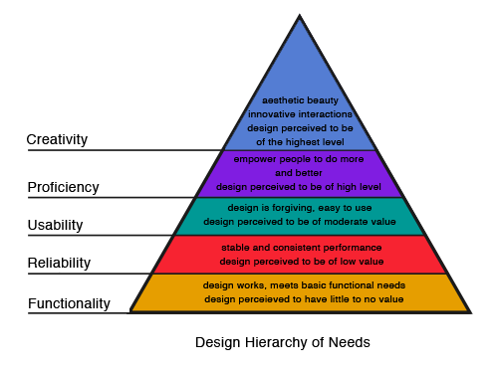

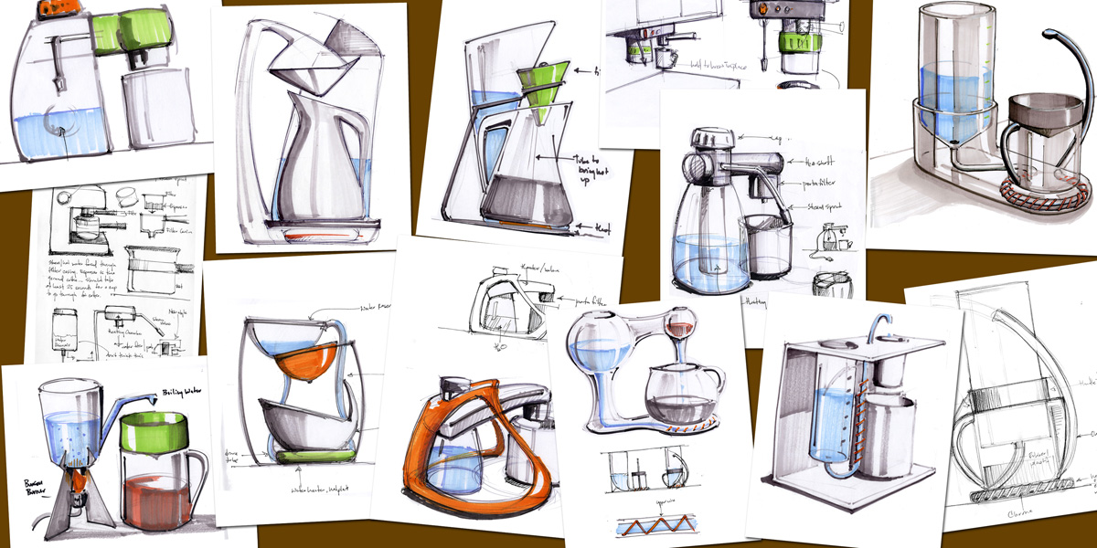

Assessment overview of the NEA

You will produce a substantial design, make and evaluate project, which consists of a portfolio and a prototype.
The assessment will be carried out under controlled conditions, as specified within the qualification's specification.
The final prototype must be produced under immediate guidance or supervision.
The portfolio will contain approximately 40 sides of A3 paper (or electronic equivalent)

There are five parts to the assessment:

Section A Overall 20 marks (Identifying and investigating design possibilities)
Identification and investigation of a design possibility, investigation of client/end user
needs, wants and values, research conclusions and practical primary research

Section B Overall 10 marks (Design Brief & Specification )
Identification and evidence of a clearly written Brief and Specification linking to previous research.

Section C Overall 25 marks (Development of Design Proposals)
Design ideas, development of design idea, final design solution, review of
development and final design and communication of design ideas

Section D Overall 25 marks (Developing design Prototypes)
Design, manufacture and realisation of a final prototype, including tools and
equipment and quality and accuracy

Section E Overall 20 marks (Analysing and Evaluating)
Testing and evaluation

