

**SIXTH FORM**



**DEPARTMENT OF MATHEMATICS**

**Bridging the gap to A Level Maths**

**INDUCTION BOOKLET**

**SUMMER 2024**

***INTRODUCTION***

The Mathematics Department is fully committed to ensuring that you make good progress throughout your A Level course. Some students find the transition from GCSE to A Level really tough so in order for you to make the best possible start to the course, we have prepared this booklet.

All students will be expected to complete this ‘Bridging the gap to A-Level’ booklet over the summer holidays. The aim of this booklet is help you understand grades 7-9 GCSE work, which is the foundation of the maths you will be studying at A-Level. It is vital that you start your A-Level course with a thorough grasp of the topics in this booklet. For each topic, there are explanations and worked examples. There are also questions for you to complete with answers in the back to allow you to check and correct your work.

There are also good revision lessons available on the Hegarty Maths and Maths Genie websites (Using the web as much as possible is also a good habit to be familiar with the content area you need to know)

**You will be assessed on these and other topics at the start of term, and you need to gain at least 80% to pass and take A Level Mathematics.**

**The A level course is done over two years. In the first year, you will go through the A/S Level content from which you will sit an internal assessment at the end of the year. The second year will cover the A2 content, after which you will sit an exam by Edexcel covering the full two years’ content.**

**The course is also divided into three sections. Pure Mathematics, Options Statistics & Mechanics assessments. The Pure is approximately 70% of the exams and Statistics & Mechanics 30%. These will be a combined score that exam boards will use to award you your final grade.**

**At Uxbridge High School, we use the Edexcel Pearson exam Board for our A Level Math course.**

Good luck

The Maths Department

**We also recommend that you access these books to bridge your gap before you actually start this course in year 12.**

[**https://alevelmathsrevision.com/bridging-the-gap/**](https://alevelmathsrevision.com/bridging-the-gap/)

[**https://www.amazon.co.uk/Head-Start-Level-Maths-2017-2018/dp/1782947922/ref=asc_df_1782947922/?tag=googshopuk-21&linkCode=df0&hvadid=310810203983&hvpos=&hvnetw=g&hvrand=12565891965879493944&hvpone=&hvptwo=&hvqmt=&hvdev=c&hvdvcmdl=&hvlocint=&hvlocphy=9046083&hvtargid=pla-487224277129&psc=1&th=1&psc=1**](https://www.amazon.co.uk/Head-Start-Level-Maths-2017-2018/dp/1782947922/ref=asc_df_1782947922/?tag=googshopuk-21&linkCode=df0&hvadid=310810203983&hvpos=&hvnetw=g&hvrand=12565891965879493944&hvpone=&hvptwo=&hvqmt=&hvdev=c&hvdvcmdl=&hvlocint=&hvlocphy=9046083&hvtargid=pla-487224277129&psc=1&th=1&psc=1)

**CONTENTS**

Chapter 1 Removing brackets page 4

Chapter 2 Linear equations 6

Chapter 3 Simultaneous equations 10

Chapter 4 Factorising 12

Chapter 5 Change the subject of the formula 15

Chapter 6 Solving quadratic equations 18

Chapter 7 Indices 20

Chapter 8 Surds 23

Chapter 9 Straight lines 25

Solutions to the exercises 29

# Chapter 1: REMOVING BRACKETS

To remove a single bracket, we multiply every term in the bracket by the number or the expression on the outside:

**Examples**

1) 3 (*x* + 2*y*) = 3*x* + 6*y*

2) -2(2*x* - 3) = (-2)(2*x*) + (-2)(-3)

= -4*x* + 6

To expand two brackets, we must multiply everything in the first bracket by everything in the second bracket. We can do this in a variety of ways, including

* the smiley face method

* FOIL (Fronts Outers Inners Lasts)

* using a grid.

**Examples**:

1) (*x* + 1)(*x* + 2) = *x*(*x* + 2) + 1(*x* + 2)

or

(*x* +1)(*x* + 2) = *x*2 + 2 + 2*x* + *x*  = *x*2 + 3*x* +2

or

|  |  |  |
| --- | --- | --- |
|  | *x* | 1  (*x* +1)(*x* + 2) = *x*2 + 2*x* + *x* + 2 = *x*2 + 3*x* +2 |
| *x* | *x*2 | *x* |
| 2 | 2*x* | 2 |

2) (*x* - 2)(2*x* + 3) = *x*(2*x* + 3) - 2(2*x* +3) = 2*x*2 + 3*x* – 4*x* - 6

= 2*x*2 – *x* – 6

or

(*x* - 2)(2*x* + 3) = 2*x*2 – 6 + 3*x* – 4*x* = 2*x*2 – *x* – 6

or

(2*x* +3)(*x* - 2) = 2*x*2 + 3*x* - 4*x* - 6 = 2*x*2 - *x* - 6

|  |  |  |
| --- | --- | --- |
|  | *x* | -2 |
| 2*x* | 2*x*2 | -4*x* |
| 3 | 3*x* | -6 |

**EXERCISE A** Multiply out the following brackets and simplify.

1. 7(4*x* + 5)
2. -3(5*x* - 7)
3. 5*a* – 4(3*a* - 1)
4. 4*y* + *y*(2 + 3*y*)
5. -3*x* – (*x* + 4)
6. 5(2*x* - 1) – (3*x* - 4)
7. (*x* + 2)(*x* + 3)
8. (*t* - 5)(*t* - 2)
9. (2*x* + 3*y*)(3*x* – 4*y*)
10. 4(*x* - 2)(*x* + 3)
11. (2*y* - 1)(2*y* + 1)
12. (3 + 5*x*)(4 – *x*)

**Two Special Cases**

**Perfect Square: Difference of two squares:**

(*x* + *a*)2  = (*x + a*)(*x + a*)= *x*2 + 2*ax* + *a*2 (*x - a*)(*x + a*) = *x*2 – *a*2

(2*x* - 3)2  = (2*x* – 3)(2*x* – 3) = 4*x*2 – 12*x* + 9 (*x* - 3)(*x* + 3) = *x*2 – 32

= *x*2 – 9

**EXERCISE B** Multiply out

1. (*x* - 1)2

2. (3*x* + 5)2

3. (7*x* - 2)2

4. (*x* + 2)(*x* - 2)

5. (3*x* + 1)(3*x* - 1)

6. (5*y* - 3)(5*y* + 3)

# Chapter 2: LINEAR EQUATIONS

When solving an equation, you must remember that whatever you do to one side must also be done to the other. You are therefore allowed to

* add the same amount to both side
* subtract the same amount from each side
* multiply the whole of each side by the same amount
* divide the whole of each side by the same amount.

If the equation has unknowns on both sides, you should collect all the letters onto the same side of the equation.

If the equation contains brackets, you should start by expanding the brackets.

A linear equation is an equation that contains numbers and terms in *x*. A linear equation does not contain any  terms.

**Example 1**: Solve the equation 64 – 3*x* = 25

**Solution**: There are various ways to solve this equation. One approach is as follows:

Step 1: Add 3*x* to both sides (so that the *x* term is positive): 64 = 3*x* + 25

Step 2: Subtract 25 from both sides: 39 = 3*x*

Step 3: Divide both sides by 3: 13 = *x*

So the solution is *x* = 13.

**Example 2**: Solve the equation 6*x* + 7 = 5 – 2*x*.

**Solution:**

Step 1: Begin by adding 2*x* to both sides 8*x* + 7 = 5

(to ensure that the *x* terms are together on the same side)

Step 2: Subtract 7 from each side: 8*x* = -2

Step 3: Divide each side by 8: *x* = -¼

**Exercise A**: Solve the following equations, showing each step in your working:

1) 2*x* + 5 = 19 2) 5*x* – 2 = 13 3) 11 – 4*x* = 5

4) 5 – 7*x* = -9 5) 11 + 3*x* = 8 – 2*x* 6) 7*x* + 2 = 4*x* – 5

**Example 3**: Solve the equation 2(3*x* – 2) = 20 – 3(*x* + 2)

Step 1: Multiply out the brackets: 6*x* – 4 = 20 – 3*x* – 6

(taking care of the negative signs)

Step 2: Simplify the right hand side: 6*x* – 4 = 14 – 3*x*

Step 3: Add 3x to each side: 9*x* – 4 = 14

Step 4: Add 4: 9*x* = 18

Step 5: Divide by 9: *x* = 2

**Exercise B:** Solve the following equations.

1) 5(2*x* – 4) = 4 2) 4(2 – *x*) = 3(*x* – 9)

3) 8 – (*x* + 3) = 4 4) 14 – 3(2*x* + 3) = 2

**EQUATIONS CONTAINING FRACTIONS**

When an equation contains a fraction, the first step is usually to multiply through by the denominator of the fraction. This ensures that there are no fractions in the equation.

**Example 4**: Solve the equation 

**Solution**:

Step 1: Multiply through by 2 (the denominator in the fraction): 

Step 2: Subtract 10: *y* = 12

**Example 5**: Solve the equation 

**Solution**:

Step 1: Multiply by 3 (to remove the fraction) 

Step 2: Subtract 1 from each side 2*x* = 14

Step 3: Divide by 2 *x* = 7

When an equation contains two fractions, you need to multiply by the lowest common denominator. This will then remove both fractions.

**Example 6**: Solve the equation 

**Solution**:

Step 1: Find the lowest common denominator: The smallest number that both 4 and 5 divide into is 20.

Step 2: Multiply both sides by the lowest common denominator 

Step 3: Simplify the left hand side: 

5(*x* + 1) + 4(*x* + 2) = 40

Step 4: Multiply out the brackets: 5*x* + 5 + 4*x* + 8 = 40

Step 5: Simplify the equation: 9*x* + 13 = 40

Step 6: Subtract 13 9*x* = 27

Step 7: Divide by 9: *x* = 3

**Example 7**: Solve the equation 

**Solution**: The lowest number that 4 and 6 go into is 12. So we multiply every term by 12:



Simplify 

Expand brackets 

Simplify 

Subtract 10*x* 

Add 6 5*x* = 24

Divide by 5 *x* = 4.8

**Exercise C**: Solve these equations

1)  2) 

3)  4) 

**Exercise C (continued)**

5)  6) 

7)  8) 

# Chapter 3: SIMULTANEOUS EQUATIONS

An example of a pair of simultaneous equations is 3*x* + 2*y* = 8 □

5*x* + *y* = 11 □

In these equations, *x* and *y* stand for two numbers. We can solve these equations in order to find the values of *x* and *y* by eliminating one of the letters from the equations.

In these equations it is simplest to eliminate *y*. We do this by making the coefficients of *y* the same in both equations. This can be achieved by multiplying equation □ by 2, so that both equations contain 2*y*:

3*x* + 2*y* = 8 □

10*x* + 2*y* = 22 2×□ = □

To eliminate the *y* terms, we subtract equation □ from equation □. We get: 7*x* = 14

i.e. *x* = 2

To find y, we substitute *x* = 2 into one of the original equations. For example if we put it into □:

10 + *y* = 11

*y* = 1

Therefore the solution is *x* = 2, *y* = 1.

**Remember**: You can check your solutions by substituting both x and y into the original equations.

**Example**: Solve 2*x* + 5*y* = 16 □

3*x* – 4*y* = 1 □

**Solution**: We begin by getting the same number of *x* or *y* appearing in both equation. We can get 20*y* in both equations if we multiply the top equation by 4 and the bottom equation by 5:

8*x* + 20*y* = 64 □

15*x* – 20*y* = 5 □

As the signs in front of 20*y* are different, we can eliminate the *y* terms from the equations by ADDING:

23*x* = 69 □+□

i.e. *x* = 3

Substituting this into equation □ gives:

6 + 5*y* = 16

5*y* = 10

So… *y* = 2

The solution is *x* = 3, *y* = 2.

**Exercise**:

Solve the pairs of simultaneous equations in the following questions:

1) *x* + 2*y* = 7 2) *x* + 3*y* = 0

3*x* + 2*y* = 9 3*x* + 2*y* = -7

3) 3*x* – 2*y* = 4 4) 9*x* – 2*y* = 25

2*x* + 3*y* = -6 4*x* – 5*y* = 7

5) 4*a* + 3*b* = 22 6) 3*p* + 3*q* = 15

5*a* – 4*b* = 43 2*p* + 5*q* = 14

# Chapter 4: FACTORISING

**Common factors**

We can factorise some expressions by taking out a common factor.

**Example 1**: Factorise 12*x* – 30

**Solution**: 6 is a common factor to both 12 and 30. We can therefore factorise by taking 6 outside a bracket:

12*x* – 30 = 6(2*x* – 5)

**Example 2**: Factorise 6*x*2 – 2*xy*

**Solution**: 2 is a common factor to both 6 and 2. Both terms also contain an *x*.

So we factorise by taking 2*x* outside a bracket.

6*x*2 – 2*xy* = 2*x*(3*x* – *y*)

**Example 3**: Factorise 9*x*3*y*2 – 18*x*2*y*

**Solution**: 9 is a common factor to both 9 and 18.

The highest power of *x* that is present in both expressions is *x*2.

There is also a *y* present in both parts.

So we factorise by taking 9*x*2*y* outside a bracket:

9*x*3*y*2 – 18*x*2*y* = 9*x*2*y*(*xy* – 2)

**Example 4**: Factorise 3*x*(2*x* – 1) – 4(2*x* – 1)

**Solution**: There is a common bracket as a factor.

So we factorise by taking (2*x* – 1) out as a factor.

The expression factorises to (2*x* – 1)(3*x* – 4)

**Exercise A**

Factorise each of the following

1) 3*x* + *xy*

2) 4*x*2 – 2*xy*

3) *pq*2 – *p*2*q*

4) 3*pq* - 9*q*2

5) 2*x*3 – 6*x*2

6) 8*a*5*b*2 – 12*a*3*b*4

7) 5*y*(*y* – 1) + 3(*y* – 1)

**Factorising quadratics**

**Simple quadratics: Factorising quadratics of the form **

The method is:

Step 1: Form two brackets (*x* … )(*x* … )

Step 2: Find two numbers that multiply to give *c* and add to make *b*. These two numbers get written at the other end of the brackets.

**Example 1**: Factorise *x*2 – 9*x* – 10.

**Solution**: We need to find two numbers that multiply to make -10 and add to make -9. These numbers are -10 and 1.

Therefore *x*2 – 9*x* – 10 = (*x* – 10)(*x* + 1).

**General quadratics: Factorising quadratics of the form **

The method is:

Step 1: Find two numbers that multiply together to make *ac* and add to make *b*.

Step 2: Split up the *bx* term using the numbers found in step 1.

Step 3: Factorise the front and back pair of expressions as fully as possible.

Step 4: There should be a common bracket. Take this out as a common factor.

**Example 2**: Factorise 6*x*2 + *x* – 12.

**Solution**: We need to find two numbers that multiply to make 6 × -12 = -72 and add to make 1. These two numbers are -8 and 9.

Therefore, 6*x*2 + *x* – 12 = 6*x*2 - 8*x* + 9*x* – 12

= 2*x*(3*x* – 4) + 3(3*x* – 4) (the two brackets must be identical)

= (3*x* – 4)(2*x* + 3)

**Difference of two squares: Factorising quadratics of the form **

Remember that  = (*x + a*)(*x – a*).

Therefore: 



Also notice that: 

and 

**Factorising by pairing**

We can factorise expressions like  using the method of factorising by pairing:

 = *x*(2*x* + *y*) – 1(2*x* + *y*) (factorise front and back pairs, ensuring both brackets are identical)

= (2*x* + *y*)(*x* – 1)

**Exercise B**

Factorise

1) 

2) 

3) 

4)  (factorise by taking out a common factor)

5) 

6) 

7) 

8) 

9) 

10) 

11) 

12) 

13) 

14) 

# Chapter 5: CHANGING THE SUBJECT OF A FORMULA

We can use algebra to change the subject of a formula. Rearranging a formula is similar to solving an equation – we must do the same to both sides in order to keep the equation balanced.

**Example 1**: Make *x* the subject of the formula *y* = 4*x* + 3.

**Solution**: *y* = 4*x* + 3

Subtract 3 from both sides: *y* – 3 = 4*x*

Divide both sides by 4; 

So  is the same equation but with *x* the subject.

**Example 2**: Make *x* the subject of *y* = 2 – 5*x*

**Solution**: Notice that in this formula the *x* term is negative.

*y* = 2 – 5*x*

Add 5*x* to both sides *y* + 5*x* = 2 (the *x* term is now positive)

Subtract *y* from both sides 5*x* = 2 – *y*

Divide both sides by 5 

**Example 3**: The formula  is used to convert between ° Fahrenheit and ° Celsius.

We can rearrange to make *F* the subject.



Multiply by 9  (this removes the fraction)

Expand the brackets 

Add 160 to both sides 

Divide both sides by 5 

Therefore the required rearrangement is .

**Exercise A**

Make *x* the subject of each of these formulae:

1) *y* = 7*x* – 1 2) 

3)  4) 

**Rearranging equations involving squares and square roots**

**Example 4**: Make *x* the subject of 

**Solution**: 

Subtract  from both sides:  (this isolates the term involving *x*)

Square root both sides: 

Remember that you can have a positive or a negative square root. We cannot simplify the answer any more.

**Example 5**: Make *a* the subject of the formula 

**Solution**: 

Multiply by 4 

Square both sides 

Multiply by *h*: 

Divide by 5: 

**Exercise B:**

Make *t* the subject of each of the following

1)  2) 

3)  4) 

5)  6) 

**More difficult examples**

Sometimes the variable that we wish to make the subject occurs in more than one place in the formula. In these questions, we collect the terms involving this variable on one side of the equation, and we put the other terms on the opposite side.

**Example 6**: Make *t* the subject of the formula 

**Solution**: 

Start by collecting all the t terms on the right hand side:

Add *xt* to both sides: 

Now put the terms without a *t* on the left hand side:

Subtract *b* from both sides: 

Factorise the RHS: 

Divide by (*y + x*): 

So the required equation is 

**Example 7**: Make *W* the subject of the formula 

**Solution**: This formula is complicated by the fractional term. We begin by removing the fraction:

Multiply by 2*b*: 

Add 2*bW* to both sides:  (this collects the W’s together)

Factorise the RHS: 

Divide both sides by *a* + 2*b*: 

**Exercise C**

Make *x* the subject of these formulae:

1)  2) 

3)  4) 

# Chapter 6: SOLVING QUADRATIC EQUATIONS

A quadratic equation has the form .

There are two methods that are commonly used for solving quadratic equations:

* factorising

* the quadratic formula

Note that not all quadratic equations can be solved by factorising. The quadratic formula can always be used however.

**Method 1: Factorising**

Make sure that the equation is rearranged so that the right hand side is 0. It usually makes it easier if the coefficient of *x*2 is positive.

**Example 1** : Solve *x*2 –3*x* + 2 = 0

Factorise (*x* –1)(*x* – 2) = 0

Either (*x* – 1) = 0 or (*x* – 2) = 0

So the solutions are *x* = 1 or *x* = 2

Note: The individual values *x* = 1 and *x* = 2 are called the **roots** of the equation.

**Example 2**: Solve *x*2 – 2*x* = 0

Factorise: *x*(*x* – 2) = 0

Either *x* = 0 or (*x* – 2) = 0

So  *x* = 0 or *x* = 2

**Method 2: Using the formula**

Recall that the roots of the quadratic equation  are given by the formula:



**Example 3**: Solve the equation 

**Solution**: First we rearrange so that the right hand side is 0. We get 

We can then tell that *a* = 2, *b* = 3 and *c* = -12.

Substituting these into the quadratic formula gives:

 (this is the *surd form* for the solutions)

If we have a calculator, we can evaluate these roots to get: *x* = 1.81 or *x* = -3.31

**EXERCISE**

1) Use factorisation to solve the following equations:

a) *x*2 + 3*x* + 2 = 0 b) *x*2 – 3*x* – 4 = 0

c) *x*2  = 15 – 2*x*

2) Find the roots of the following equations:

a) *x*2 + 3*x* = 0 b) *x*2 – 4*x* = 0

c) 4 *– x*2 = 0

3) Solve the following equations either by factorising or by using the formula:

a) 6*x*2  - 5*x* – 4 = 0 b) 8*x*2 – 24*x* + 10 = 0

4) Use the formula to solve the following equations to 3 significant figures. Some of the equations can’t be solved.

a) *x*2 +7*x* +9 = 0 b) 6 + 3*x* = 8*x*2

c) 4*x*2 – *x* – 7 = 0 d) *x*2 – 3*x* + 18 = 0

e) 3*x*2 + 4*x* + 4 = 0 f) 3*x*2 = 13*x* – 16

**Chapter 7: INDICES**

**Basic rules of indices**

. 4 is called the **index** (plural: indices), **power** or **exponent** of *y*.

There are 3 basic rules of indices:

1)  e.g. 

2)  e.g. 

3)  e.g. 

**Further examples**



 (multiply the numbers and multiply the *a*’s)

 (multiply the numbers and multiply the *c*’s)

 (divide the numbers and divide the *d* terms i.e. by subtracting the powers)

**Exercise A**

Simplify the following:

1)  = (Remember that )

2)  =

3)  =

4) =

5)  =

6)  =

7)  =

8)  =

**More complex powers**

**Zero index:**

Recall from GCSE that

.

This result is true for any non-zero number *a*.

Therefore 

**Negative powers**

A power of -1 corresponds to the reciprocal of a number, i.e. 

Therefore 



 (you find the reciprocal of a fraction by swapping the top and bottom over)

This result can be extended to more general negative powers: .

This means:







**Fractional powers:**

Fractional powers correspond to roots: 

In general:



Therefore:

  

A more general fractional power can be dealt with in the following way: 

So 





**Exercise B:**

Find the value of:

1) 

2) 

3) 

4) 

5) 

6) 

7) 

8) 

9) 

10) 

11) 

12) 

Simplify each of the following:

13) 

14) 

15) 

**Chapter 8: SURDS**

Surds are square roots of numbers which don’t simplify into a whole (or rational) number: e.g.  but it is more accurate to leave it as a surd:

**General rules**





But you cannot do:



These are NOT equal



**Simplifying Surds**

Find the largest square numbers and simplify as far as possible

Worked Examples

 Careful - this is “3 times the square root of 2” NOT “the cube root of 2”

**Rationalising the Denominator**

This is a fancy way of saying getting rid of the surd on the bottom of a fraction. We multiply the fraction by the denominator (or the denominator with the sign swapped)

**Worked Examples**

1.  we multiply by  which is the same as multiplying by 1, which means we don’t fundamentally change the fraction.

2. 

3.

4. 

**Exercise A:**

Simplify the surds

1. 
2. 
3. 
4. 
5. 

**Exercise B:**

Expand and simplify

1. 
2. 
3. 
4. 
5. 
6. 
7. 
8. 
9. 

**Exercise C**:

Rewrite the following expressions with rational denominators

 

# Chapter 9: Straight line graphs

Linear functions can be written in the form *y* = *mx* + *c*, where *m* and *c* are constants.

A linear function is represented graphically by a straight line, *m* is the gradients and *c* is the *y-*intercept of the graph.

**Example 1**: Draw the graph of *y* = 2*x* + 1

 **Solution**:

Step 1: Make a table of values



Step 2: Use your table to draw the straight line graph

**Example 2**: Plot the straight line using the gradient and y intercept

**Solution**:

Step 1: Mark on the y axis the *y-*intercept = 2

Step 2: The gradient=  so start from the *y*­*–* intercept

for every 1unit across to the right go down by half a unit

and mark a second point there.

Step 3: Join the *y* intercept with the new point with a line and extend form both sides.

.

Here are some examples of linear functions not all of them in the form *y* = *mx* + *c.* You need to be confident into rearranging the functions making *y* the subject in order to identify the gradient and *y-* intercept.

*y* = **2***x* + **3** 3*x* - 2*y* + 1 = 0 4*y* - *x* = 3

so  so 

gradient= 2 gradient=  gradient=

*y-*intercept= 3 *y-*intercept=  *y-*intercept= 

  

To find the *y*-axis crossing, substitute *x* = 0 into the linear equation and solve for *y*.

To find the *x*-axis crossing, substitute *y* = 0 into the linear equation and solve for *x*.

**Example 3**: Rewrite the equation 3*y -* 2*x* = 5 into the form *y* = *mx* + *c,* find the gradient and the *y-*intercept

**Solution**:

Step 1: Add 2*x* to both sides (so that the *x* term is positive): 3*y* = 5 + 2*x*

Step 2: Divide by 3 both sides: 

Step 3: Identify the gradient and *y-*intercept gradient=  *y-*intercept= 

**Example 4**: Find the gradient of the line which passes through the points A (1, 4) and B (-3, 2)

**Solution**:

Step 1: Use the *x* and *y* values of A and B  

Step 2: find the gradient 

Finally you need to be able to find the equation of a line from a graph.

**Example 5**: Find the equation of the straight line which passes through the point (1, 3) and has gradient 2

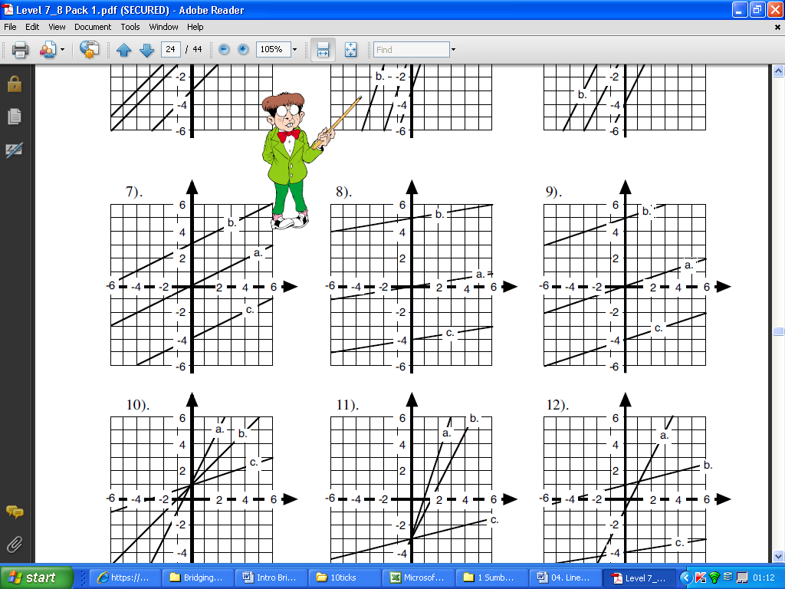

**Solution:**

Step 1: Find where the line crosses the y axis.

This is the *y* intercept,  *c.*

Line crosses y axis at 5,

so y-intercept c=5

Step 2: Draw a triangle below the line from the intercept to a point you know

And work out the gradient between the two points 

Gradient triangle from (-6,3) to (0,5) so 

Step 3: Write in the form *y* = *mx* + *c* 

**Exercise A**: Plot the graph of each function taking the given values

1. *y= x -*  3 (  *x =* -2 to 4)
2. *y=- x +* 4 (  *x =* -2 to 5)
3. *y =* 2*x –* 3 (  *x =* -1 to 5)
4. *y=* -3*x* + 5 (  *x =* -2 to 3)

**Exercise B:**

Rewrite the equations below into the form *y* = *mx* + *c,* find the gradient and the *y*-intercept

a)3*x – 2y – 2 =* 0 b) *x* + 2*y* – 8 =0 c) 5 = 4*x – 2y*

Then plot the graph of each equation

**Exercise C:**

Work out the gradient between the sets of coordinates

1. A ( 0, 2) and B( 3, 6)
2. A ( 1, 0) and B( 3, -2)
3. A ( 1, -3) and B( 2, -4)
4. A ( -4, 2) and B( 3, 5)
5. A ( 1, 0.5) and B( 5, -2)
6. A ( -7, -3) and B( -2, -6)

**Exercise D:**

Find the equation of these lines in the form

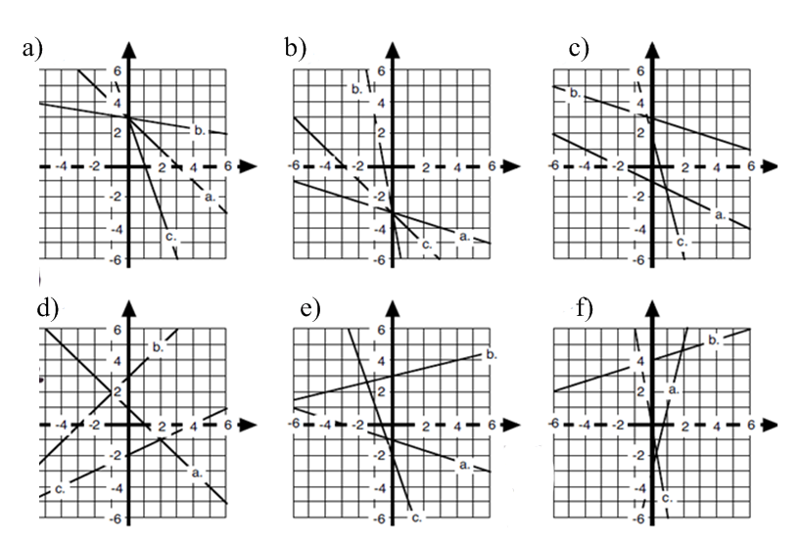

**SOLUTIONS TO THE EXERCISES**

**CHAPTER 1:**

Ex A

1) 28*x* + 35 2) -15*x* + 21 3) -7*a* + 4 4) 6*y* + 3*y*2 5) 2*x* – 4

6) 7*x* – 1 7) *x*2 + 5x + 6 8) *t*2 – 3*t* – 10 9) 6*x*2 + *xy* – 12*y*2

10) 4*x*2 + 4*x* – 24 11) 4*y*2 – 1 12) 12 + 17*x* – 5*x*2

Ex B

1) *x*2 – 2*x* + 1 2) 9*x*2 + 30*x* + 25 3) 49*x*2 – 28*x* + 4 4) *x*2 – 4

5) 9*x*2 -1 6) 25*y*2 – 9

**CHAPTER 2**

Ex A

1) 7 2) 3 3) 1½ 4) 2 5) -3/5 6) -7/3

Ex B

1) 2.4 2) 5 3) 1 4) ½

Ex C

1) 7 2) 15 3) 24/7 4) 35/3 5) 3 6) 2 7) 9/5 8) 5

Ex D

1) 34, 36, 38 2) 9.875, 29.625 3) 24, 48

**CHAPTER 3**

1) *x* = 1, *y* = 3 2) *x* = -3, *y* = 1 3) *x* = 0, *y* = -2 4) *x* = 3, *y* = 1

5) *a* = 7, *b* = -2 6) *p* = 11/3, *q* = 4/3

**CHAPTER 4**

Ex A

1)  *x*(3 + *y*) 2) 2*x*(2*x* – *y*) 3) *pq*(*q* – *p*) 4) 3*q*(*p* – 3*q*) 5) 2*x*2(*x* - 3) 6) 4*a*3*b*2(2*a*2 – 3*b*2)

7) (*y* – 1)(5*y* + 3)

Ex B

1) (*x* – 3)(*x* + 2) 2) (*x* + 8)(*x* – 2) 3) (2*x* + 1)(*x* + 2) 4) *x*(2*x* – 3) 5) (3*x* -1 )(*x* + 2)

6) (2*y* + 3)(*y* + 7) 7) (7*y* – 3)(*y* – 1) 8) 5(2*x* – 3)(*x* + 2) 9) (2*x* + 5)(2*x* – 5) 10) (*x* – 3)(*x* – *y*)

11) 4(*x* – 2)(*x* – 1) 12) (4*m* – 9*n*)(4*m* + 9*n*) 13) *y*(2*y* – 3*a*)(2*y* + 3*a*) 14) 2(4*x* + 5)(*x* – 4)

**CHAPTER 5**

Ex A

1)  2)  3)  4) 

Ex B

1)  2)  3)  4)  5)  6) 

Ex C

1)  2)  3)  4) 

**CHAPTER 6**

1) a) -1, -2 b) -1, 4 c) -5, 3 2) a) 0, -3 b) 0, 4 c) 2, -2

3) a) -1/2, 4/3 b) 0.5, 2.5 4) a) -5.30, -1.70 b) 1.07, -0.699 c) -1.20, 1.45

d) no solutions e) no solutions f) no solutions

**CHAPTER 7**

Ex A

1) 5*b*6 2) 6*c7* 3) *b*3*c*4 4) -12*n*8 5) 4*n*5 6) *d*2 7) *a*6 8) -*d*12

Ex B

1) 2 2) 3 3) 1/3 4) 1/25 5) 1 6) 1/7 7) 9 8) 9/4 9) ¼ 10) 0.2 11) 4/9 12) 64

13) 6*a*3  14)  *x* 15) *xy*2­­

**CHAPTER 8**

**ExA**



**ExB**



**Ex C**

 

**CHAPTER 9**

**ExB :**  

**ExC :**

**Ex D :** a) a. y = -x+3 b. y = -0.25x+3 c. y = -3x+3

b) a. y = -x-3 b. y = -6x – 3 c. y = -x – 3

c) a. y = -0.5x -1 b. y = -x + 3 c. y = -4x +2

d) a. y = -x +1 b. y = x + 3 c. y = 0.5x - 2

e) a. y = -x – 1 b. y = 0.25x + 3 c. y = -3x - 2

f) a. y = 4x -2 b. y = x + 4 c. y = -6x