|  |  |
| --- | --- |
|  | |
|  |  |

[Uxbridge High School](https://www.uhs.org.uk/)

Y12 Transition Homework

AS Required Practical’s

Past Examination Questions

Use the practical summary sheet and AQA Handbook to recap the methods for Practical’s 1-6

<https://filestore.aqa.org.uk/resources/physics/AQA-7407-7408-PHBK.PDF>

**Q1.**

Lengths of copper and iron wire are joined together to form junctions J1 and J2. When J1 and J2 are at different temperatures an emf *ε* is generated between them. This emf is measured using a microvoltmeter.

**Figure 1** shows J1 kept at 0 °C while J2 is heated in a sand bath to a temperature *θ* measured by a digital thermometer.

**Figure 1**

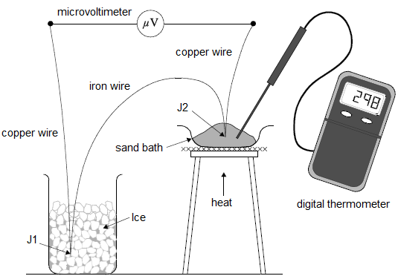

An experiment is carried out to determine how *ε* depends on *θ*.

The results of the experiment are shown in the table below and a graph of the data is shown in **Figure 2**.

|  |  |
| --- | --- |
| ***θ* / °C** | ***ε* / μV** |
| 200 | 1336 |
| 226 | 1402 |
| 258 | 1450 |
| 298 | 1456 |
| 328 | 1423 |
| 362 | 1345 |
| 392 | 1241 |

**Figure 2**

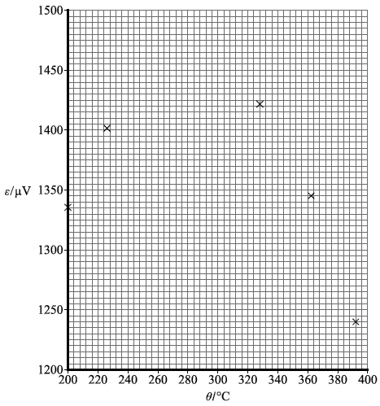

(a)     Plot the points corresponding to *θ* = 258 °C and *θ* = 298 °C on **Figure 2**.

**(1)**

(b)     Draw a suitable best fit line on **Figure 2**.

**(1)**

(c)     Determine the maximum value of *ε*.

maximum value of *ε* = ____________________ μV

**(1)**

(d)     The gradient *G* of the graph in **Figure 2** is measured for values of *θ* between 220 °C and 380 °C. A graph of *G* against *θ* is plotted in **Figure 3**.

**Figure 3**

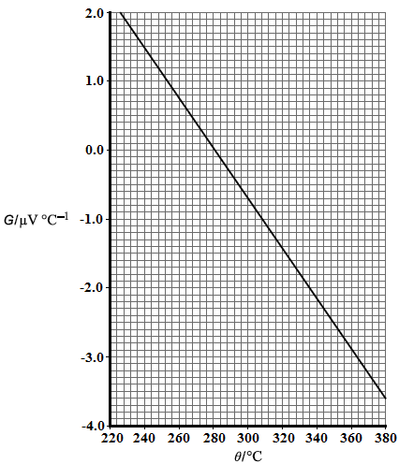

The neutral temperature *θ*n is the temperature corresponding to the maximum value of *ε*. *θ*n can be determined using either **Figure 2** or **Figure 3**.

Explain why a more accurate result for *θ*n may be obtained using **Figure 3**.

___________________________________________________________________

___________________________________________________________________

___________________________________________________________________

___________________________________________________________________

___________________________________________________________________

**(1)**

(e)     It can be shown that *G* is given by

*G* = *βθ* + *α*

where *α* and *β* are constants.

Determine *α*.

*α* = ____________________ μV °C−1

**(2)**

(f)      A student decides to carry out a similar experiment. The student thinks the meter in **Figure 4** could be used as the microvoltmeter to measure *ε*.

**Figure 4**

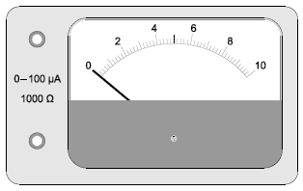

When this meter indicates a maximum reading and the needle points to the right-hand end of the scale (full-scale deflection), the current in the meter is 100 μA. The meter has a resistance of 1000 Ω.

Calculate the full-scale deflection of this meter when used as a microvoltmeter.

full-scale deflection = ____________________ μV

**(1)**

(g)     The scale on the meter has 50 divisions between zero and full-scale deflection.

Discuss why this meter is not suitable for carrying out the experiment.

___________________________________________________________________

___________________________________________________________________

___________________________________________________________________

___________________________________________________________________

___________________________________________________________________

___________________________________________________________________

**(2)**

**(Total 9 marks)**

**Q2.**

(a)     (i)      Describe how you would make a direct measurement of the emf *ɛ* of a cell, stating the type of meter you would use.

______________________________________________________________

______________________________________________________________

**(1)**

(ii)     Explain why this meter must have a very high resistance.

______________________________________________________________

______________________________________________________________

**(1)**

(b)     A student is provided with the circuit shown in the diagram below.

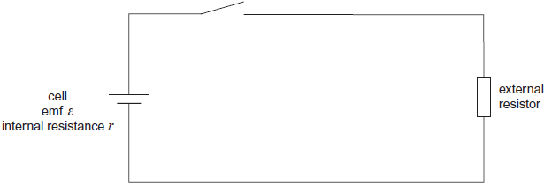

The student wishes to determine the efficiency of this circuit.

In this circuit, useful power is dissipated in the external resistor. The total power input is the power produced by the battery.

Efficiency = 

The efficiency can be determined using two readings from a voltmeter.

(i)      Show that the efficiency =  where *ɛ* is the emf of the cell

and *V* is the potential difference across the external resistor.

**(1)**

(ii)     Add a voltmeter to the diagram and explain how you would use this new circuit to take readings of *ɛ* and *V*.

______________________________________________________________

______________________________________________________________

______________________________________________________________

**(2)**

(c)     Describe how you would obtain a set of readings to investigate the relationship between efficiency and the resistance of the external resistor. State any precautions you would take to ensure your readings were reliable.

___________________________________________________________________

___________________________________________________________________

___________________________________________________________________

___________________________________________________________________

___________________________________________________________________

___________________________________________________________________

___________________________________________________________________

___________________________________________________________________

**(2)**

(d)     State and explain how you would expect the efficiency to vary as the value of *R* is increased.

___________________________________________________________________

___________________________________________________________________

___________________________________________________________________

___________________________________________________________________

___________________________________________________________________

___________________________________________________________________

**(2)**

**(Total 9 marks)**

**Q3.**

A student has a diffraction grating that is marked 3.5 × 103 lines per m.

(a)     Calculate the percentage uncertainty in the number of lines per metre suggested by this marking.

percentage uncertainty = ____________________ %

**(1)**

(b)     Determine the grating spacing.

grating spacing = ____________________ mm

**(2)**

(c)     State the absolute uncertainty in the value of the spacing.

absolute uncertainty = ____________________ mm

**(1)**

(d)     The student sets up the apparatus shown in **Figure 1** in an experiment to confirm the value marked on the diffraction grating.

**Figure 1**

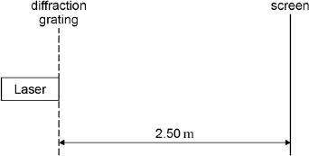

The laser has a wavelength of 628 nm. **Figure 2** shows part of the interference pattern that appears on the screen. A ruler gives the scale.

**Figure 2**

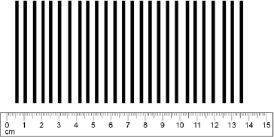

Use **Figure 2** to determine the spacing between two adjacent maxima in the interference pattern. Show all your working clearly.

spacing = ____________________ mm

**(1)**

(e)     Calculate the number of lines per metre on the grating.

number of lines = ____________________

**(2)**

(f)    State and explain whether the value for the number of lines per m obtained in part (e) is in agreement with the value stated on the grating.

___________________________________________________________________

___________________________________________________________________

___________________________________________________________________

**(2)**

(g)   State **one** safety precaution that you would take if you were to carry out the experiment that was performed by the student.

___________________________________________________________________

___________________________________________________________________

___________________________________________________________________

**(1)**

**(Total 10 marks)**

**Q4.**

(a)

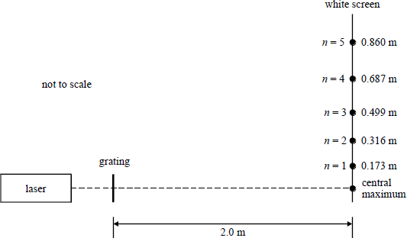

**Figure 1**

In a laboratory experiment, monochromatic light of wavelength 633 nm from a laser is incident normal to a diffraction grating. The diffracted waves are received on a white screen which is parallel to the plane of the grating and 2.0 m from it. **Figure 1** shows the positions of the diffraction maxima with distances measured from the central maximum.

By means of a graphical method, use all these measurements to determine a mean value for the number of rulings per unit length of the grating.

___________________________________________________________________

___________________________________________________________________

___________________________________________________________________

___________________________________________________________________

___________________________________________________________________

___________________________________________________________________

___________________________________________________________________

___________________________________________________________________

___________________________________________________________________

___________________________________________________________________

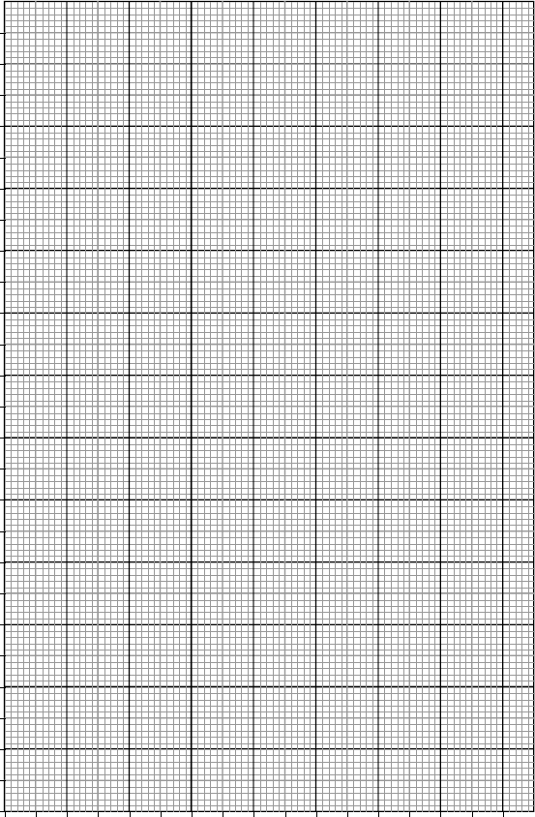

**(6)**

(b)     Describe and explain the effect, if any, on the appearance of the diffraction pattern of

(i)       using a grating which has more rulings per unit length.

______________________________________________________________

______________________________________________________________

______________________________________________________________

(ii)      using a laser source which has a shorter wavelength.

______________________________________________________________

______________________________________________________________

______________________________________________________________

(iii)     increasing the distance between the grating and the screen.

______________________________________________________________

______________________________________________________________

______________________________________________________________

**(6)**

(c)     **Figure 2**, below, shows the diffracted waves from four narrow slits of a diffraction grating similar to the one described in part (a). The slit separation AB = BC = CD = DE = *d* and EQ is a line drawn at a tangent to several wavefronts and which makes an angle *θ* with the grating.

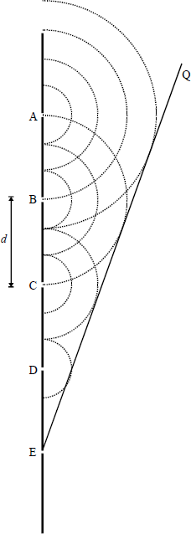

**Figure 2**

(i)      Explain why the waves advancing perpendicular to EQ will reinforce if superposed.

______________________________________________________________

______________________________________________________________

______________________________________________________________

(ii)     Show that this will happen when sin *θ* = 

______________________________________________________________

______________________________________________________________

______________________________________________________________

**(3)**

**(Total 15 marks)**

**Q5.**

The first section of a full-size stroboscopic photograph of a marble released from rest and in free fall is shown below. Every time the strobe light flashes an image of the marble is recorded. The time interval between successive flashes of the strobe light was 0.0435 s.

(a)     This photograph can be used to find a value for the acceleration due to gravity *g*.

(i)     Take measurements from the diagram below that can be used to find an accurate value for *g*.

**(2)**

(ii)     Calculate a value for *g* using your measurements from **(a)(i)**.

______________________________________________________________

______________________________________________________________

______________________________________________________________

______________________________________________________________

______________________________________________________________

______________________________________________________________

______________________________________________________________

**(2)**

(b)     Suggest why the duration of the flash of the strobe should be as short as possible.

___________________________________________________________________

___________________________________________________________________

___________________________________________________________________

**(1)**

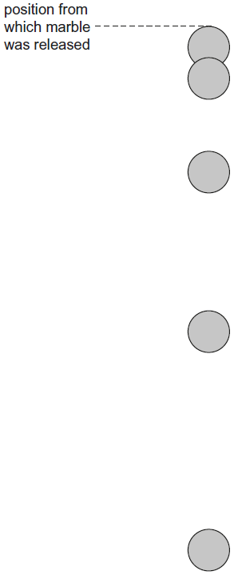

**(Total 5 marks)**

**Q6.**

This question is about the determination of the Young modulus of the metal of a wire.

In an experiment, two vertical wires **P** and **Q** are suspended from a fixed support. The fixed part of a vernier scale is attached to **P** and the moving part of the scale is attached to **Q**. The divisions on the fixed part of the scale are in mm.

An empty mass hanger is attached to **Q** and the scale is set to zero. A load is added to the mass hanger so that the extension of **Q** can be measured as shown in **Figure 1**.

**Figure 1**

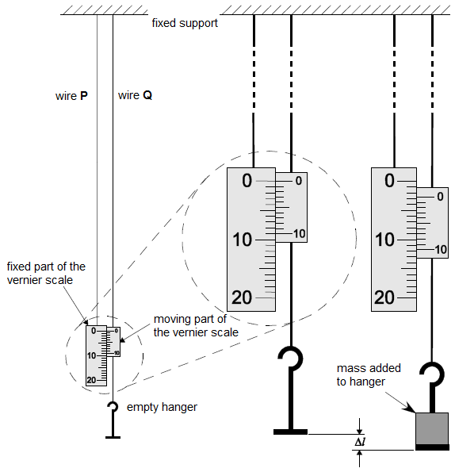

(a)     The reading on the vernier scale can be used to determine ∆*l*, the extension of **Q**.

Determine ∆*l* using **Figure 1**.

∆*l* = ____________________ mm

**(1)**

(b)     **Figure 2** shows how ∆*l* varies with *m*, the mass added to the hanger.

Determine the mass added to the hanger shown in **Figure 1**.

**Figure 2**

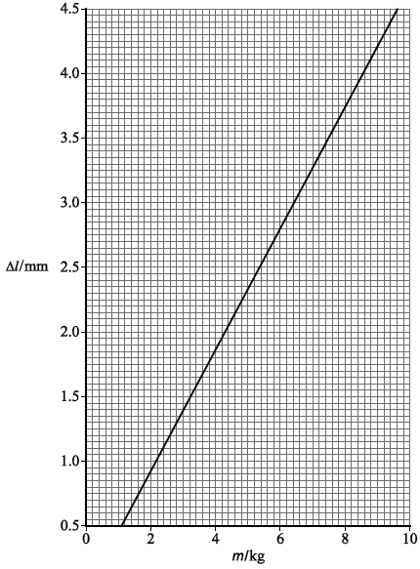

mass = ____________________ kg

**(1)**

(c)     A student uses digital vernier callipers to measure the diameter of **Q**. She places **Q** between the jaws of the callipers and records the reading indicated. Without pressing the zero button she removes **Q** and closes the jaws.

Views of the callipers before and after she closes the jaws are shown in **Figure 3**.

**Figure 3**

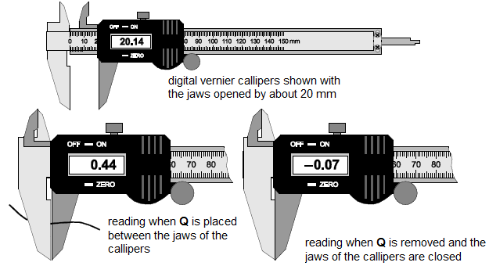

Calculate the true diameter of **Q**.

diameter = ____________________ mm

**(1)**

(d)     The original length of **Q** was 1.82 m.

Determine the Young modulus of the metal in **Q**.

Young modulus = ____________________ Pa

**(4)**

(e)     The student repeats her experiment using a wire of the same original length and metal but with a smaller diameter.

Discuss **two** ways this change might affect the percentage uncertainty in her result for the Young modulus.

1. _________________________________________________________________

___________________________________________________________________

___________________________________________________________________

___________________________________________________________________

2. _________________________________________________________________

___________________________________________________________________

___________________________________________________________________

___________________________________________________________________

**(4)**

**(Total 11 marks)**

**Q7.** The table below shows the results of an experiment where a force was applied to a sample of metal.

(a)     On the axes below, plot a graph of stress against strain using the data in the table.

|  |  |  |  |  |  |  |  |  |  |  |  |
| --- | --- | --- | --- | --- | --- | --- | --- | --- | --- | --- | --- |
| Strain / 10–3 | 0 | 1.00 | 2.00 | 3.00 | 4.00 | 5.00 | 6.00 | 7.00 | 8.00 | 9.00 | 10.00 |
| Stress /108 Pa | 0 | 0.90 | 2.15 | 3.15 | 3.35 | 3.20 | 3.30 | 3.50 | 3.60 | 3.60 | 3.50 |

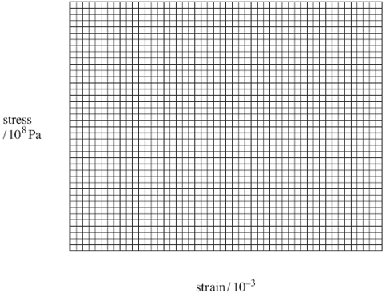

**(3)**

(b)     Use your graph to find the Young modulus of the metal.

answer = ______________________ Pa

**(2)**

(c)     A 3.0 m length of steel rod is going to be used in the construction of a bridge. The tension in the rod will be 10 kN and the rod must extend by no more than 1.0mm. Calculate the minimum cross-sectional area required for the rod.

Young modulus of steel = 1.90 × 1011 Pa

answer = ______________________ m2

**(3)**

**(Total 8 marks)**

**Q8.**

A ‘potato cell’ is formed by inserting a copper plate and a zinc plate into a potato. The circuit shown in **Figure 1** is used in an investigation to determine the electromotive force and internal resistance of the potato cell.

**Figure 1**

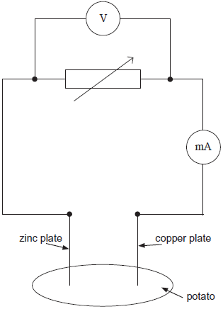

(a)     State what is meant by electromotive force.

___________________________________________________________________

___________________________________________________________________

___________________________________________________________________

___________________________________________________________________

**(2)**

(b)     The plotted points on **Figure 2** show the data for current and voltage that were obtained in the investigation.

**Figure 2**

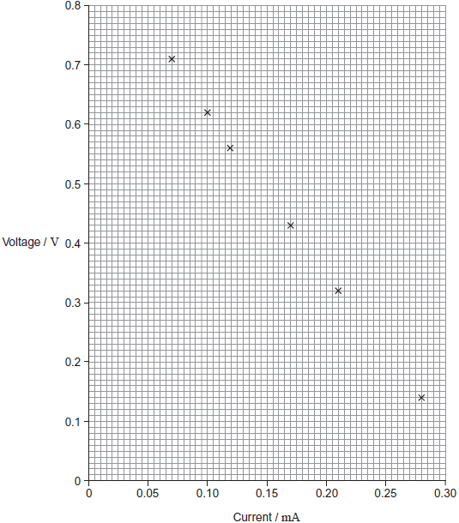

(i)      Suggest what was done to obtain the data for the plotted points.

______________________________________________________________

______________________________________________________________

______________________________________________________________

______________________________________________________________

**(1)**

(ii)     The electromotive force (emf) of the potato cell is 0.89 V. Explain why the voltages plotted on **Figure 2** are always less than this and why the difference between the emf and the plotted voltage becomes larger with increasing current.

______________________________________________________________

______________________________________________________________

______________________________________________________________

______________________________________________________________

______________________________________________________________

______________________________________________________________

______________________________________________________________

**(3)**

(iii)    Use **Figure 2** to determine the internal resistance of the potato cell.

internal resistance = ____________________ Ω

**(3)**

(c)     A student decides to use two potato cells in series as a power supply for a light emitting diode (LED). In order for the LED to work as required, it needs a voltage of at least 1.6 V and a current of 20 mA.

Explain whether the LED will work as required.

___________________________________________________________________

___________________________________________________________________

___________________________________________________________________

___________________________________________________________________

___________________________________________________________________

___________________________________________________________________

**(2)**

**(Total 11 marks)**

**Q9.**

A student investigates the variation of electric potential with distance along a strip of conducting paper of length *l* and of uniform thickness. The strip tapers uniformly from a width 4*w* at the broad end to 2*w* at the narrow end, as shown in **Figure 1**. A constant pd is applied across the two ends of the strip, with the narrow end at positive potential, *Vl*, and the broad end at zero potential. The student aims to produce a graph of pd against distance *x*, measured from the broad end of the strip.

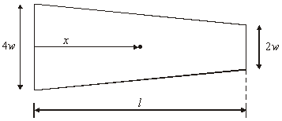

**Figure 1**

(a)     Draw a labelled circuit diagram which would be suitable for the investigation.

**(2)**

(b)     The student obtained some preliminary measurements which are shown below.

|  |  |  |  |  |
| --- | --- | --- | --- | --- |
| pd, *V*/V | 0 | 2.1 | 4.5 | 7.2 |
| Distance, *x*/m | 0 | 0.100 | 0.200 | 0.300 |

By reference to the physical principles involved, explain why the increase of *V* with *x* is greater than a linear increase.

___________________________________________________________________

___________________________________________________________________

___________________________________________________________________

___________________________________________________________________

___________________________________________________________________

___________________________________________________________________

___________________________________________________________________

___________________________________________________________________

**(4)**

(c)     The potential, *V*, at a distance *x* from the broad end is given by

*V* = *k* – 1.44*Vl* ln (2*l* – *x*),

where *Vl* is the potential at the narrow end, and *k* is a constant.

(i)      The student’s results are given below. Complete the table.  
*l* = 0.400 m

|  |  |  |  |
| --- | --- | --- | --- |
| distance *x*/m | potential *V*/V | (2*l* – *x*)/m | ln (2*l* – *x*) |
| 0.100 | 2.1 | 0.700 | – 0.357 |
| 0.200 | 4.5 |  |  |
| 0.270 | 6.4 |  |  |
| 0.330 | 8.3 |  |  |
| 0.360 | 9.3 |  |  |
| 0.380 | 10.1 |  |  |

(ii)     Plot a graph of *V* against ln (2*l* – *x*) and explain whether or not it confirms the equation.

______________________________________________________________

______________________________________________________________

______________________________________________________________

______________________________________________________________

______________________________________________________________

______________________________________________________________

______________________________________________________________

______________________________________________________________

______________________________________________________________

(iii)     Use the graph to calculate *Vl*.

______________________________________________________________

______________________________________________________________

**(10)**

**(Total 16 marks)**

**Q10.**

In an attempt to investigate how the resistance of a filament lamp varies with current through the lamp, a student obtains the results shown in the table.

|  |  |  |  |  |  |  |
| --- | --- | --- | --- | --- | --- | --- |
| voltage/V | 0.50 | 1.50 | 3.00 | 4.50 | 6.00 | 12.00 |
| current/A | 0.51 | 1.25 | 2.00 | 2.55 | 2.95 | 4.00 |
| resistance/Ω |  |  |  |  |  |  |

(a)     Complete the table by calculating the corresponding values of resistance.

**(2)**

(b)     (i)      On the grid below plot a graph of resistance against current for the filament lamp.

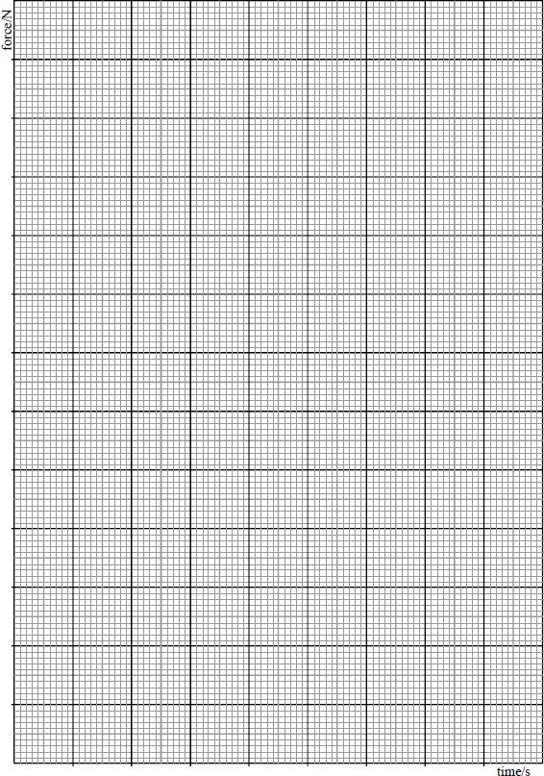

(ii)     Use your graph to estimate the resistance of the filament lamp when no current flows through the lamp.

______________________________________________________________

(iii)    Use your graph to determine the change in the resistance of the filament when the current increases

from 0 to 1.0 A, _________________________________________________

______________________________________________________________

from 1.0 A to 2.0 A ______________________________________________

______________________________________________________________

(iv)    Calculate the power dissipated in the lamp filament when the current through the filament is 1.0 A and 2.0 A.

1. ____________________________________________________________

______________________________________________________________

2. ____________________________________________________________

______________________________________________________________

**(8)**

(c)     Using information from part (b)(iv), explain why the change in resistance of the filament is less for a current change of 0 to 1.0 A than for a current change of 1.0 A to 2.0 A. Do **not** attempt any calculation.

___________________________________________________________________

___________________________________________________________________

___________________________________________________________________

**(2)**

**(Total 12 marks)**